**Case Subsea-tech**

Subsea-tech make special sensors for use in subsea installations. They have 3 products, Subsea1, Subsea2 and Subsea3. Table 1 shows the prices:

| **Product** | **Subsea1** | **Subsea2** | **Subsea3** |
| --- | --- | --- | --- |
| **Price** | 100.000 | 150.000 | 200.000 |

**Table 1**

Table 2 shows the direct cost components:

| **Product** | **Subsea1** | **Subsea2** | **Subsea3** |
| --- | --- | --- | --- |
| Direct cost | 60.976 | 121.065 | 20.964 |

**Table 2**

An ABC project has resulted in the following table 3:

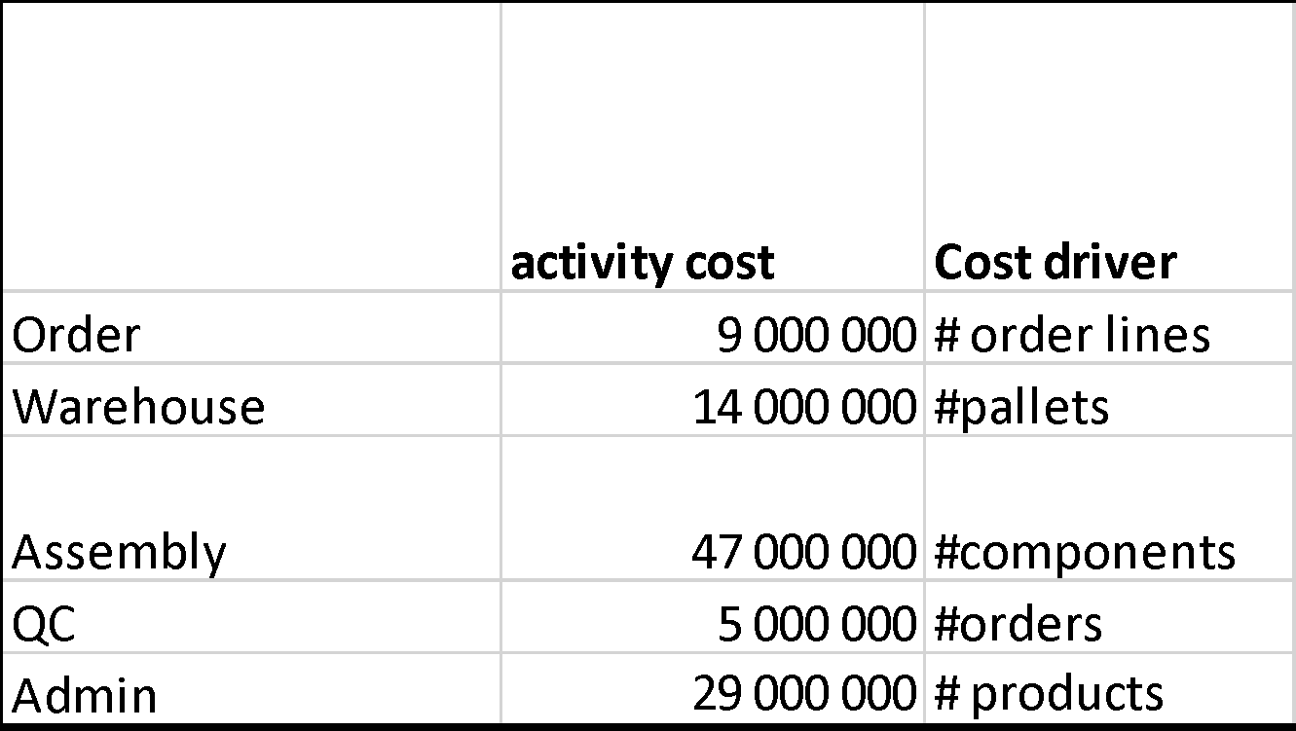

**Table 3**

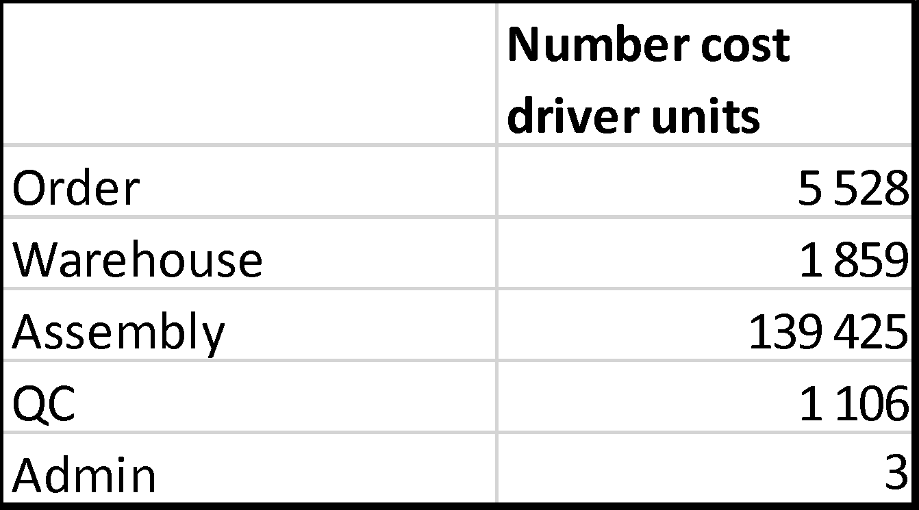

**Table 4**

Information about the number of cost driver units the various products consumed has also been compiled:

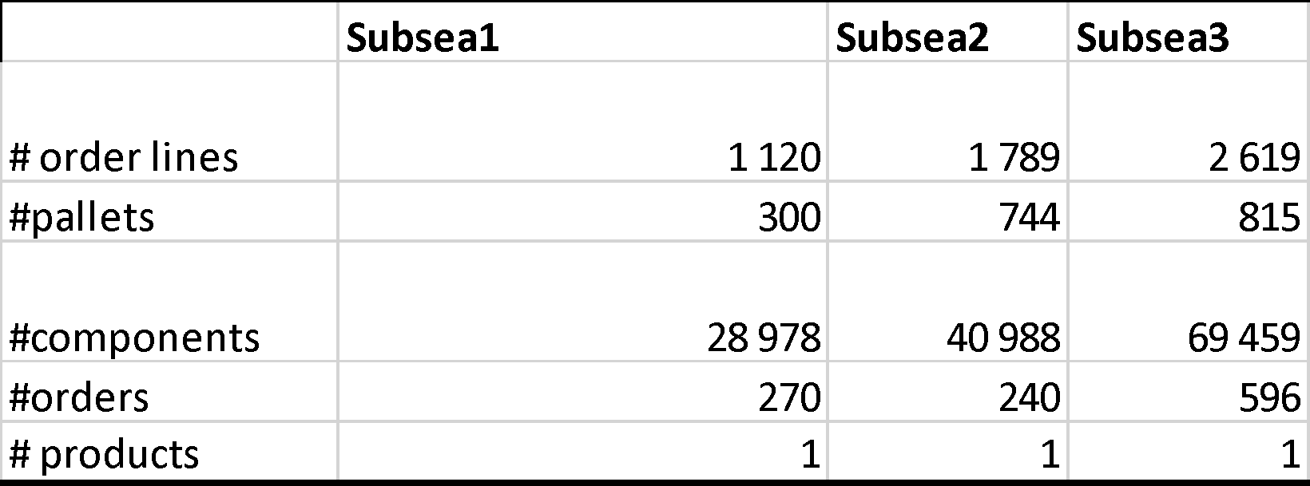

**Table 5**

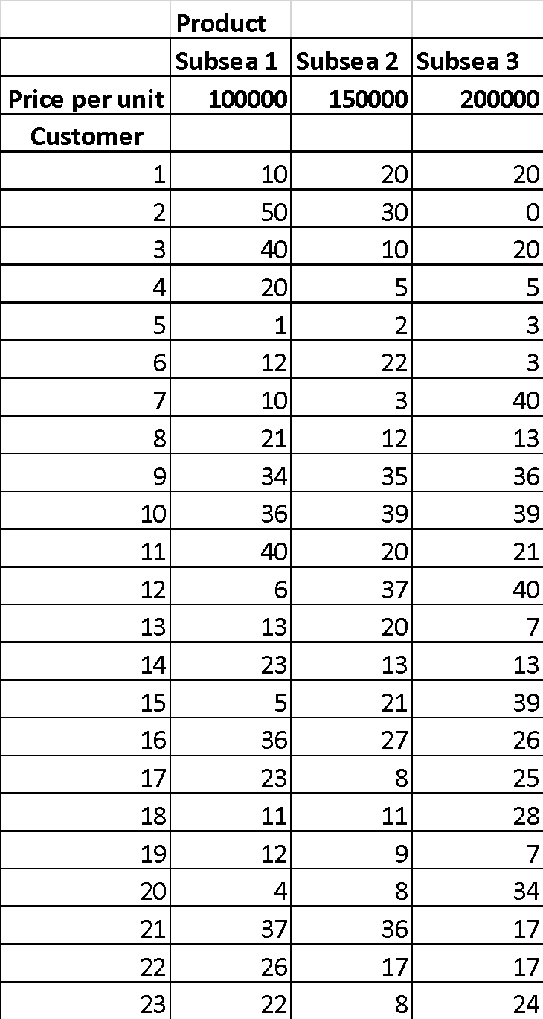

**Table 6 – Number units**

a)

Find the per unit profit for each product, and the total for SubseaTech.

b)

Using the product profitability numbers from a), compute the customer profitability for each customer, and show this also in the form of a Stobachoff curve.

c)

Is there some easy way to communicate how homogenous the customer group is (or is not) in terms of profitability?

d)

In table 7 the company has obtained further detailed data related to the customers:

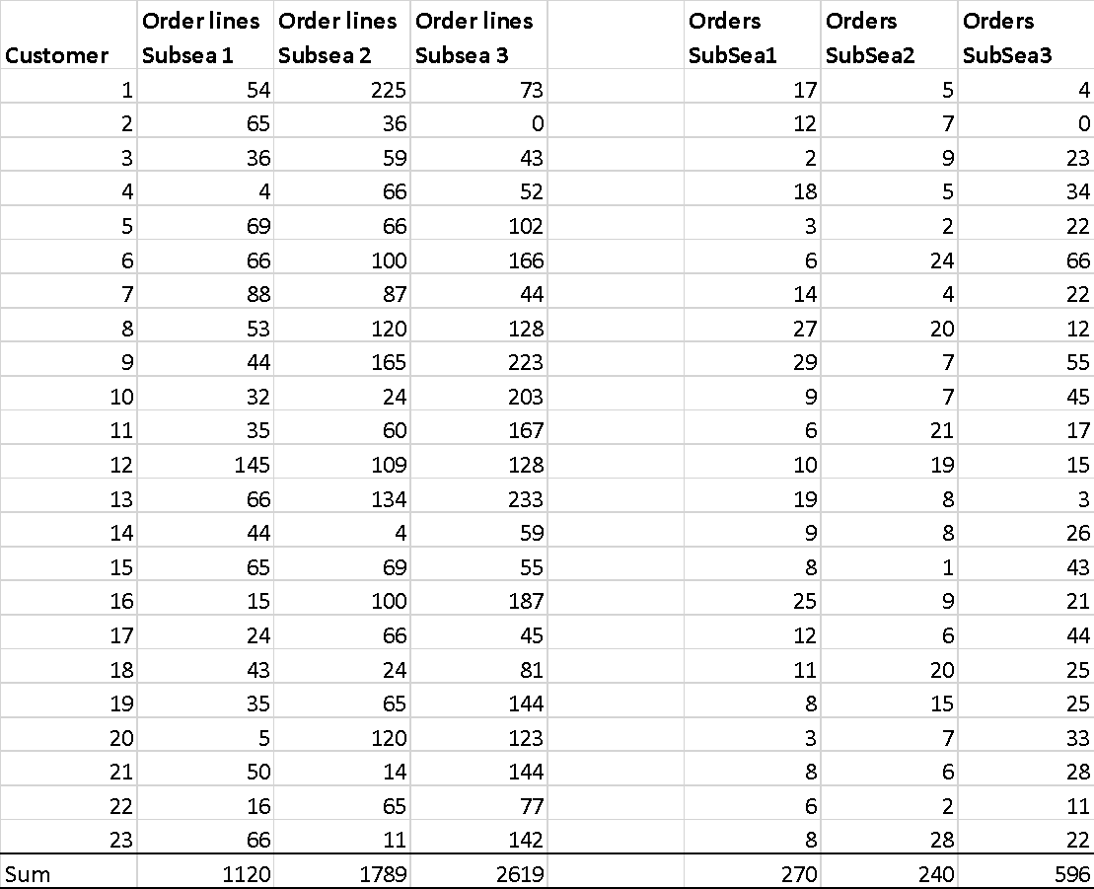

**Tabell 7**

Conduct a new analysis of customer profitability and contrast this answer with your previous answer both in numbers and graphically.